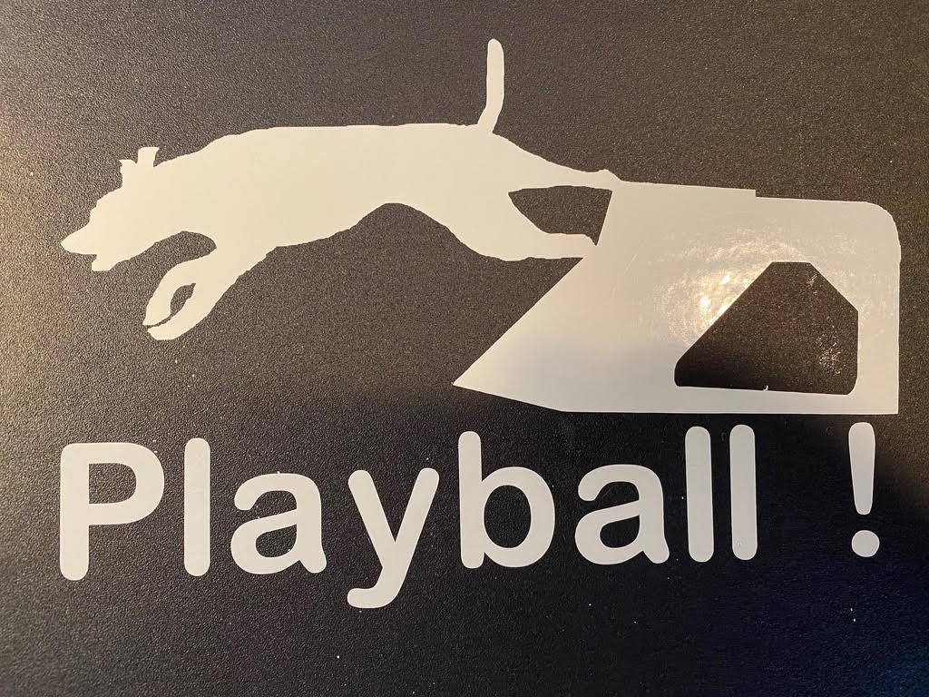

Blockade Runners Flyball is excited to welcome you to our Playball 2021 tournament!!
We are having 2 single day tournaments with Friday evening Preflight.

We are glad you have decided to join us in these unprecedented times. All forms and information mentioned in this letter can be found at
Blockaderunnersflyball.com Playball2021 section forms

COVID waiver must be signed by all participants prior to entering the building. In addition to the U Fli Group waiver. Both forms are available Blockaderunnersflyball.com If possible please have your team sign the form and email it to the tournament director at flyingratdog@gmail.com prior to the event.

I was delighted at the overwhelming response with entries. We had double the amount of entries we could accommodate.

I am pleased to offer your team the following entries
______preflight on Friday March 12. Starting at 3pm
______preflight on Saturday March 13
______standard team Saturday March 13
______standard team Sunday March 14
______pairs team Saturday March 13
______pairs team Sunday March 14
______singles Saturday March 13
______singles Sunday March 14

Please forward confirmed seed times ( I already have this for most teams) and payment to Pam Schwentner via

Old fashioned snail mail Pam Schwentner
Checks to Pam Schwentner 715 Harolds N Field Dr.
Cedar Grove NC 27231

Paypal @pamelaschwentner
flyingratdog@gmail.com
919 260 7176

Cash app $pamschwentner

Schedule

Friday March 12th
3pm Preflight begins
3pm building open for placement of boxes/equipment
7pm-730p Measuring
9pm- building closed

Saturday March 13th-
7am building opens
730am measuring will be outdoors in front of the exhibit hall
8am captains meeting in front of exhibit hall
815am Racing starts
Lunch after race_____
Preflight will be held during lunch break and at the completion of racing

Sunday March 14th
7am building opens
730 measuring
745 possible Captains meeting only if necessary
8am racing starts
Lunch after race____

The tournament is being held at the Halifax County Fairgrounds located at 1188 James D Hagood Hwy. South Boston, VA 24592. The fairgrounds are located behind the South Boston Speedway. The fairgrounds website is https://www.halifaxcountyva.gov/?SEC=A21BBB08-FC1D-4541-8FCD-06BC02D14321

Racing will be held in the exhibit hall.

Map of fairgrounds located in forms section of Blockaderunnersflyball.com

Warm ups will be 2 minutes on Sat and 1 min on Sunday

Lodging
Quality Inn 2001 Seymour Dr. South Boston. If you call and ask for Andy he will give a $25 pet fee for the weekend regardless of the number of dogs per room. Use the group name “Playball 2021” phone number 434 572 4311. This hotel is about 3 miles from the site and there is an attached restaurant Badeaux’s Seafood and Grill.
https://www.choicehotels.com/virginia/south-boston/quality-inn-hotels

On site RV hookups can be reserved/secured with prepayment in advance through Halifax County. Available on a first reserve basis. Please indicate if you require 30 or 50 amp hook ups. Water and electrical are included. Application form and map of fairgrounds located on the website

On site food truck will be provided by John Dunaway of Smok’n Butts BBQ. He will be offering breakfast and lunch options. His specialty is BBQ, both pork and chicken. He comes highly recommended for good food at reasonable prices.

Judge for the weekend will be Kevin Hesse

Onsite Vendors-
Amy Beth from Honey Snuggles handmade http://honeysnuggleshandmade.com/
Neil Restorff from Smashville Speedsters with Bucketdogz.com treats
Bucketdogz.com or on facebook at Bucket Dogs

There will be a raffle to help offset the costs of hosting a tournament. $1 per ticket, 6 for $5, stretch for $20. Raffle will be drawn on Sunday afternoon at approximately 1 pm. IF you are interested in donating a raffle item please contact Meg Arpe at megnponcho@yahoo.com.
We are going to trial a hybrid of cash or electronic payment for tickets.

Flyball Geek ring assignment system will be used. The schedule can be accessed at
http://www.flyballgeek.com/v/1418

Please bring no touch devices for ball shagging and a sufficient amount of newly washed balls to reduce the number of times a ball is touched and reused over the course of the event.

Jump setters will sanitize their hands prior to touching the jumps.

Preflight- This is a great time for beginner dogs. Each 7 min time frame will start with the ring completely set up and must end with the ring completely set up. (all 4 jumps in place) There will be only 1 team in the ring at a time. You may use 1 lane or 2. A maximum of 2 dogs in the ring/building at a time during preflight. (dog that is entered and a training dog as needed)
Remember dogs in Preflight can not enter any other class that day.

Please be sure to clean up after your dog. Poop bags and garbage receptacles will be provided around the grounds. Thank you for your cooperation.

Unfortunately we will not be able to have an awards ceremony. Race results will be available on posters however at the end of racing we will be unable to gather and congratulate each other. Please put all your new titles and brags on the Midatlantic UFLI Facebook page.

Team lineups may be changed or a performance team may be declared up until the first race of their respective division has started. After a race has been run in a division no lineups may be changed. Please check the race forms carefully.

Please read the following COVID precautions prior to attending.

COVID precautions- UFLi is committed to working with flyball clubs and local health departments to provide the safest events possible during this unprecedented time. The following guidelines and mandates constitute the plan to prevent transmission of COVID during the event. Strict adherence to these guidelines is required by UFli, state and local government and the Blockade Runners Flyball Team.

Masks are required to be worn at all times in the building and outside if you are less than 6 feet apart. Masks must be worn properly covering the nose and mouth.

Masks must contain 2 or more layers, completely cover nose and mouth, fit snuggly against the sides of your face. No Gators or bandanas. Face shields may be worn in addition to but not in replacement of a mask.

One warning for no mask, or an ill fitting mask in the ring. No second warnings. In order for U-FLI to continue to sanction tournaments throughout this pandemic, we need 100% compliance. Everyone must wear a mask properly at all times or be removed from the tournament.

If you are having difficulty with your mask, please ask me. I wear a mask 40+ hours a week and have developed some good tricks to help with eye glass fogging, fitting etc.

-There will no indoor crating or spectators allowed.

• There will be a specified entrance and exit for traffic flow clearly marked in the racing building for access to the respective lanes and exit doors.

• Hand sanitizer stations will be set up at head table, box judge areas, and exits and entrances of the building. Please cleanse your hands every time you enter the building.

• Only judges, workers, and teams actively racing will be allowed in the racing building. Teams on deck will need to wait outside until the previous teams have exited the building. In the event of rain, we will have designated waiting areas set up. One person from each team on deck will be allowed to come in and get box/balls/props ready and let the box judge know what jump height to set.

• There will be areas designated for storing boxes, balls, and props. Each club must keep their items within their own space. No sharing of props between clubs unless permission is granted ahead of time.

• Jumps heights will be set by the line and/or box judge. If you need heights changed during racing let either the line or box judge know, and they will change for you.

• All doors of the racing building will be open at all times to allow more airflow and avoid needing to touch door handles. We will make an exception for preflight – if you need them closed let the head table know and we will close for you.

• There will be taped off areas around the head table, line judge, and box judges. A clear barrier will be placed between the line judge and pass caller.

• Commonly touched objects will be wiped down regularly. There will be clean and dirty pen/pencil containers that will be sanitized regularly.

• No paper schedules will be provided, teams will need to print their own.

• When not in the racing building, it is expected participants will continue to follow CDC guidelines.

All in attendance are asked to refrain from hand shaking and personal contact between participants.

Please maintain social distancing for crating, rotation to and from the ring, after parties, team campsites and all other aspects of the event.

Emergency resources- If a member of your team is a human or canine medical practitioner that will be attending the event please notify me privately. I would like to have a list of “go to” persons on site in the event of an emergency. This does not obligate that person in any way to provide care.

Emergency Vet
Triangle Veterinary Referral Hospital
608 Morreene Rd
Durham, NC
919 489 0615
Www..triangleVRH.com
Open 24 hours

Animal Emergency and Critical Care of Lynchburg
3432 Odd Fellows Rd
Lynchburg, VA 24501
434 846 1504
M-F 6pm-8am
Weekends open 24 hours

Local Hospital-
Sentara Halifax Regional Hospital
2204 Wilborn Ave
South Boston, VA 24592

Trauma center
Duke University Health Center
2301 Erwin Rd
Durham NC 27710
919 684 8111

If you have any questions or suggestions please contact the tournament director Pam Schwentner at 919 260 7176 flyingratdog@gmail.com

I look forward to a great return to flyball.

Respectfully,
Pam Schwentner
Tournament director

